REPUBLIC OF RWANDA OFFICE OF THE OMBUDSMAN


9th COMMONWEALTH REGIONAL CONFERENCE OF HEADS OF ANTI-CORRUPTION AGENCIES IN AFRICA

PUBLIC PROCUREMENT PRESENTATION

KAMPALA/ UGANDA FROM 6th-11th May 2019

KAMPALA/ UGANDA FROM 5th -11th May 2019

Table of Contents

1. Brief introduction and background 3
2. Innovative work or initiatives implemented 5
E-Procurement System based on Rwanda public procurement processes 5
3. Main challenges faced in implementing the initiatives 8
4. Results of the innovation 9
5. Reflections and lessons learnt 10
6. Recommendations 10

Brief introduction and background

- The Government of Rwanda has undertaken a number of Anti-corruption measures coupled with immense political will, zero tolerance to corruption and public support.
- The Office of The Ombudsman was established in 2003 by the Constitution of The Republic of Rwanda of 2003 revised in 2015 (article 139).
- The Office of The Ombudsman’ mission are provided for in article 4 of the Law nº 76/2013 of 11/09/2013 determining the mission, powers, organization and functioning of The Office of The Ombudsman.
- The Office of The Ombudsman is a hybrid institution which deals at the same time with addressing injustice complaints; preventing and combating corruption and promoting integrity and transparency.
- "There can be no doubt that corruption is very costly to both governments and businesses and as such impacts negatively on our development efforts (H.E. Paul Kagame, The President of The Republic of Rwanda).
- Rwanda's commitment to fighting corruption has led to the enactment of many laws covering anti-corruption:
- Law nº 44bis/2017 relating to protection of whistleblowers;
- Law n° 42/2014 of 27/01/2015 governing recovery of offence-related assets;
- Law n° 54/2018 of 13/08/2018 on fighting against corruption;
- Law nº 69/2018 of 31/08/2018 on prevention and punishment of money laundering and terrorism financing money laundering, and terrorism financing.
- Importantly, corruption offenses in Rwanda are "imprescriptible" that is, they are not subject to any statute of limitations.
- Specialized chambers at Intermediate Court level were established to prosecute corruption. The court system in Rwanda is headed by the Supreme Court, with the Court of Appeal, the High Court, Twelve Intermediate Courts, and Forty-one Primary Courts.
- Each Intermediate Court now has specialized chamber for corruption and other economic crimes.
- Public and private institutions, civil society and international organizations are required to implement mechanisms for the prevention of corruption. The Office of The Ombudsman has the power to request administrative sanctions against the Leader of an organization that fails to comply with Rwanda's corruption prevention measures.
- To meet the ambitious transformation goal set by the Government of Rwanda, digital technologies are shaping the Rwandan society in fighting against corruption.

2. Innovative work or initiatives implemented

- The Government of Rwanda put in place E-Procurement System for Rwanda (UMUCYO). The Rwanda E-Procurement System automates the public procurement processes and enables the interactions of Government to Business Services ( G2B).

E-Procurement System based on Rwanda public procurement processes
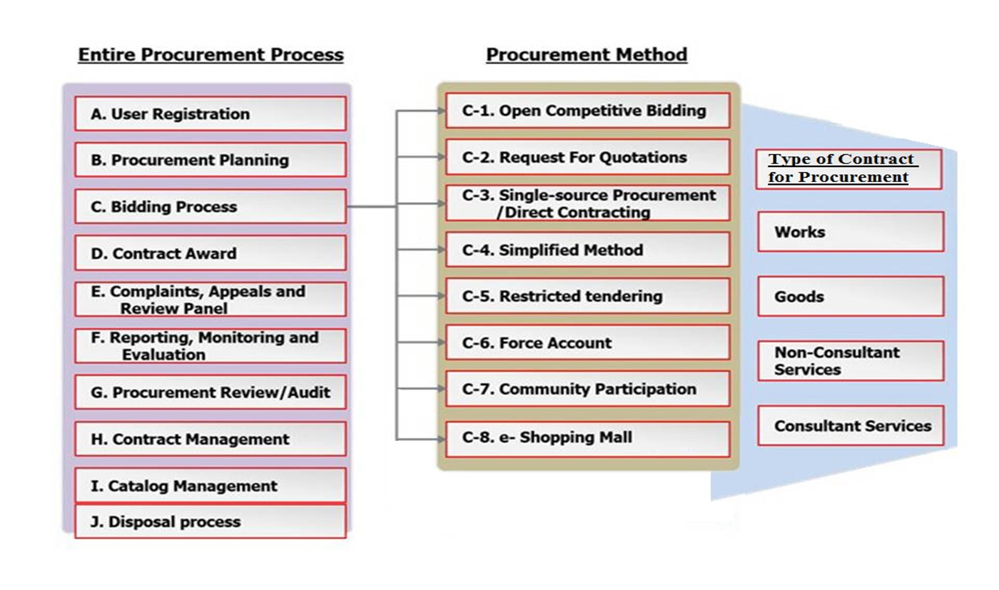

Procurement process is divided into the following parts:
A. User registration
All bidders must be register in the procurement system
B. Procurement planning
A procuring entity prepare public procurement plan while preparing the budget and submit to Rwanda Public procurement through e- Procurement System.
C. Bidding process
All procurement activities must be done in the system (Bid document, advertisement, opening of the tender, evaluation, etc.).
D. Contract award
Procuring entity prepares contract through the system
E. Complaints, appeals, and Panels review
- At any time from the publication of the tender to the signing of the contract, a bidder may request for review to the procuring entity in case he/she is not satisfied with the procurement proceedings. A request for review must be made in writing through the system
- Independent Review Panels is composed of seven (7) members appointed for a one period of four (4) years. They are drawn from the public sector, private sector and civil society.
- Appeals to Rwanda Public Procurement Authority within seven (7) days from the day of notification of the decision of the procuring entity.
F. Reporting, Monitoring and Evaluation

Every procuring entity must insert in the system. The report shows how the procurement plan is being implemented
G. Procurement Review/Audit
E- Procurement System allows the internal auditors and Auditor General review the implementation of the Public procurement.
H. Contact management

The procuring entity must be represented by the supervising official, in contract execution

I. Catalog Management

E-Procurement has a database of products and services that Public Entities need to purchase.
J. Disposal Process
E-Procurement has a window where the public institutions record the used Assets to be sold in auction
- By using the online system, the Government purchases goods, works, services and non-consultancy services to help the Government to ensure efficiency of public procurement with the standardization of electronic documents, supplier registration, goods and services information and to streamline public procurement transactions for efficient government service delivery.

- Since July 2016, this system has been implemented in 8 Government entities ( 3 Ministries, 3 Agencies and 2 districts) and its deployment in the remaining entities started with July 2017(Central Government Institutions and Local Governments on District Level) .The use of the E-Procurement System requires the prior registration of suppliers and procuring entities in the system.
The system facilitates international suppliers to register without physical checking of their documents and they can participate in tendering as well as sign contracts via E- Procurement system (online) without their presence in Rwanda.
- Documents from external linkage (securities, RSSB, RRA Certificates Trade licence and Credit line) come from the systems of respective organisations and sometimes have missing data. In this case procuring entities are advised to seek clarification from the issuing organizations document or from E-Procurement Project before decision is made. This will avoid unfair qualification of bidders and further complaints which may result.

3. Main challenges faced in implementing the initiatives
Rwanda has made impressive strides over the years towards ICT development and developing ICT as a crosscutting enabler for the development of other sectors. However, some challenges remain and more efforts are need, especially in the e-procurement system:
- External linkage systems can sometimes be a source of technical issues: We constantly work with linkage systems owners to fix any issues
- Procuring entities should consult document( from external linkage systems) issuing entities or the Project Support Team to avoid unfairly disqualifying bidders or lengthy claims
- Double work preparing online and offline contract

4. Results of the innovation
- Reduced risks of corruption in public procurement in Rwanda by reducing physical contact between suppliers and government officials;
- Reduced public procurement time & cost by using online processing for the entire procurement process (example the cost on advertisement of the tender, cost of print out of tender documents, filling space of document related to the tender, etc..)
- Efficiency of public procurement with the standardisation of electronic documents, supplier registration, goods and services information;
- Establishing of a single channel and portal for public procurement contracts;
- Achieving value for money for government by cutting corruption
channels to get sufficient information on products and suppliers;

5. Reflections and lessons learnt
- Political will constitute a key pillar in adopting and implementing anti-corruption initiatives;
- It is of paramount importance to focus on prevention, education, collaboration, enforcement as well as monitoring and evaluation while fighting against corruption;
- The ICT Sector is increasingly occupying an important position in Rwanda’s endevous to achieve the targets associated with the National Strategy for Transformation and the vision 2050 goals with Zero tolerance to corruption.

6. Recommendations
- No Country is immune from corruption and governments need to work together and with partners from business and civil society to tackle corruption successfully.
- The political will and leadership committed to eradicate corruption should be considered as bedrock in the fight against corruption.
- We should put more efforts on prevention rather than enforcement and engage youth with positive values as future leaders since low ages.
- E-Procurement is an efficient system to limit corruption in public procurement (Africa loses $148 billion to corruption every year as said by Akinwumi Adesina, The President of the African Development Bank).
- E-Procurement and E-Payment Systems are key innovative activities to fight against corruption.

